Day 38 – Solution Design

What is Solution Design?
Solution design means converting a business problem into a step-by-step data science solution.
It connects:
- Business goals
- Data
- Analytics
- Machine Learning
- Deployment
- Business impact
Flow :
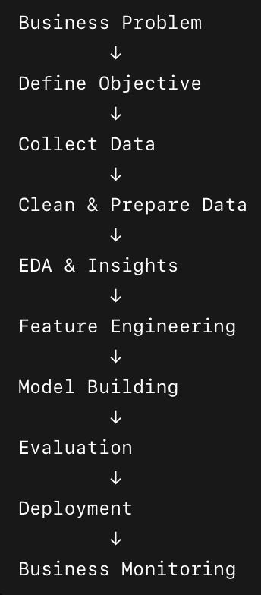
Understand the Business Problem
We must ask clarifying questions:
- What exactly is the issue?
- Why does it matter?
- Who is affected?
- What does success look like?

Example
Business Problem:
An e-commerce company is losing customers.
Bad DS approach:
“Let’s build a neural network.”
Good DS approach:
“Why are customers leaving? Can we predict churn early?”

Convert Business Problem into DS Problem
Business people speak in revenue, cost, growth, efficiency.
Data scientists convert that into:
- Classification
- Regression
- Clustering
- Forecasting
- Recommendation systems

Mapping Examples
Business Problem | DS Problem Type
Customers leaving | Classification
Predict sales | Regression/Forecasting
Fraud detection | Anomaly Detection
Customer segmentation | Clustering
Product recommendations | Recommendation System
Demand prediction | Time Series Forecasting

Define Success Metrics.

Example

Business Goal
Reduce customer churn by 20%

DS Metrics
- Precision
- Recall
- F1-score
- ROC-AUC

Business KPI
- Retention rate
- Revenue saved
- Customer lifetime value

Data Collection
Now we need to identify:
- What data is needed?
- Is data available?
- Structured or unstructured?
- Internal or external?

Example Sources
Source | Example
Database | Customer transactions
API | Weather data
Logs | Website clicks
Surveys | Customer feedback
Social Media | Reviews/comments

Data Preparation
Raw data is usually give bad prediction and accuracy so we need to prprocess the data accordingly.
It include:
- Handling missing values
- Removing duplicates
- Encoding categories
- Normalization
- Text preprocessing

Exploratory Data Analysis (EDA)
Goal:
Understand patterns before modeling.
Questions:
- Which features matter?
- Any trends?
- Any anomalies?
- Any imbalance?

Example
For churn prediction:
- Customers with low activity churn more
- Long support wait times increase churn
- Premium users churn less
These insights themselves can help business teams.

Feature Engineering
This heps to prevent data leakage and choosing correct feature will always give a good result..
We create useful variables from raw data.

Example
Raw Data:
Login timestamps
Engineered Feature:
Average weekly login frequency
More meaningful.

Model Selection
Choose model based on:
- Problem type
- Data size
- Explainability
- Speed
- Business constraints

Example
Problem | Possible Models
Churn Prediction | Logistic Regression, Random Forest
Sales Forecasting | ARIMA, Prophet, LSTM
Recommendation | Collaborative Filtering
Fraud Detection | Isolation Forest, XGBoost

Model Evaluation
We should not blindly trust accuracy. Because Data leakage can happen and sometimes the model misses the fraud cases. Eventhough the accuracy gives around 99% it might have missed fraud cases so a model with more than 75% accuracy with missing fraud cases better than a model with accuracy more than 95% and missing many fraud cases. So Recall becomes Important.

Example
Fraud detection:
- Accuracy may be 99%
- But model misses fraud cases
So recall is important here.

Deployment
A notebook is not a product. So we need to host the application so the user can understand easily and can access efficiently. So we need to deploy the app that we built on notebook.
Deployment means:
- API
- Web app
- Dashboard
- Cloud integration
- Automation

Example Tools
Purpose | Tools
API | FastAPI, Flask
Frontend | React
Cloud | AWS, Azure
Monitoring | Grafana

Monitoring & Feedback Loop
Models degrade over time. So We need to update the model or market changes, or new patterns have been found and need modification over time and make it run seamlessly without any interruption once it gets deployed and users are using the application.
So we will do:
- Retraining
- Monitoring drift
- Updating features

Real-Time Example:

Problem
Netflix wants to reduce subscription cancellations.

Solution Design Mapping for this problem statement would be :

Business Layer | DS Layer
Users cancel subscriptions | Predict churn
Improve retention | Classification model
Use watch history | Collect behavioral data
Identify risky users | Feature engineering
Predict churn probability | Train ML model
Notify retention team | Deploy dashboard/API
Measure improvement | Track retention KPI

